BUILD THE BOGIE APPEAL
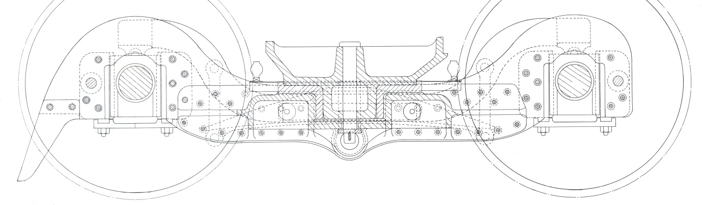
What better way to lead a New Build project than to start with the front set of wheels and frames!
Our first construction appeal is to make a start on the front bogie assembly, the purpose of the bogie is to lead and guide the locomotive around corners. It is only fitting we lead with it on our first build appeal.
We aim to acquire the various component parts required to build the bogie, storing them until we have secured a suitable location to begin the construction of Ben Alder. The components will be produced in stages, starting with the frame side plates, as the funds increase and we launch the second stage of the appeal, the further items such as axle boxes and suspension will be added. Our first target is to raise £10,000; this will allow us to cut the side plates, complete the bulk of design work and establish accurate quotes for bogie completion. Once this stage is complete, we will roll out the second stage of the bogie appeal with further perks and rewards in thanks for your contribution.
For this first stage, we are asking for either a one-off donation or regular monthly contributions (requested contribution of £20pm for 12 months), all donors/monthly contributors meeting the standard subscription will automatically be added to the supporters group. Those who choose to donate a regular monthly donation (£10pm minimum) will also receive a printed copy of the new bogie General Arrangement drawing (once the design work has been completed), a bogie appeal certificate, as well as the standard supporters pack.
Please fill in your details on the reverse of this form, if you are making a single donation, only give your contact details in part 1.
If you wish to make a monthly contribution, please complete parts 1 and 2
From all the team on the Ben Alder Project,
Thank you
. Build the Bogie Appeal
Please complete and hand to one of the NBLS team, or Post to
NBLS, Blackcraigs, Kirkcaldy, Fife, KY2 6TL
(Part 1)
Name: _____________________________________________
Address:________________________________________________________________________________________________________________________________________________________ Post Code: _________________________
Email:_______________________________________________________________________________
Single Donation amount: £_____________________ Method: Cash/Cheque
I am a standard (age 16-60) supporter / a concession (under 16 or over 60) supporter.
(Please sign the bottom of the form if you wish to be part of the supporters group).

(Part 2)
Standing order Mandate
To the manager, I wish to pay a monthly sum of £________ to New Build Locomotive Scotland. I understand that the amount will be paid at monthly intervals as indicated.
BANKERS ORDER TO___________________________________________________________(your bank)
BANK ADDRESS:______________________________________________________________________________
Post Code:__________________ Acc No:______________________ Sort code:___________________
(* Delete as appropriate) Please pay £_____________ to New Build Locomotive Scotland, Bank of Scotland, Acc No: 17561764, Sort Code: 80-22-60 from the above, on the (date)__________of each month beginning (date)____________ *until (date)______________ (or) *until I give further notice.
Signed___________________________ Date________________________ Ref (leave blank):____________
Data Protection: New General Data Protection Regulations came into force on 25 May 2018. We are committed to protecting your personal information and will not share your details with any organisation outside New Build Locomotive Scotland. Details of your subscription and/or individual donations will be processed solely for our own administrative purposes but may be shared with the Revenue & Customs (HMRC). We will not make contact directly with your sponsors.
.

